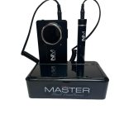 | NailMaster | Draadloze Professionele Freesmachine 801- 40.000RPM-Black | €0,00 | × 1
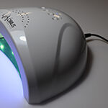 | Dual Led Light 24/48 watt / 2 stuks set | €0,00 | × 1
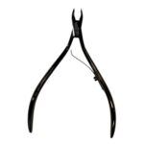 | NM Expert CT/4mm Cuticle Tang Single Spring | €0,00 | × 1
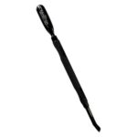 | NM Cuticle Pusher Black | €0,00 | × 1
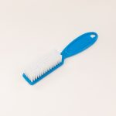 | Manicure borstel - blauw  Variatie-ID: 9417 | €0,00 | × 1
  color: | blauw
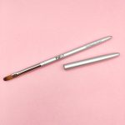 | NailMaster | Penseel - Gel Master - Oval 6 | €0,00 | × 1
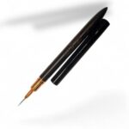 | NM Liner Penseel 6mm | €0,00 | × 1
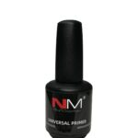 | Nailmaster | Universal Primer Acid Free | 15ml - 15 ml  Artikelnummer: PrAcFr150-LY111H9NM914-15ML1  Variatie-ID: 12603 | €0,00 | × 1
  Hoeveelheid: | 15 ml
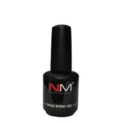 | Nailmaster | Base Bond Gel 15ml Clear - 15 ml  Artikelnummer: BaBoGlTR-C5DJ22NM914-15ML1  Variatie-ID: 12599 | €0,00 | × 1
  Hoeveelheid: | 15 ml
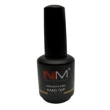 | NailMaster | Hard Top No Wipe 15ml Hema/Tpo free  Artikelnummer: HT-H&T-NM914.C9FC83-15ML | €0,00 | × 1
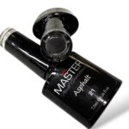 | NailMaster | Asphalt 7,5ml – 21  Artikelnummer: 21-572NM914-7,5ML | €0,00 | × 1
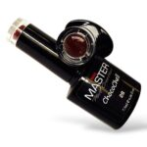 | NailMaster | ChocoChell 28 /7,5ml  Artikelnummer: 28NM914.517-7,5ML | €0,00 | × 1
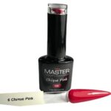 | NailMaster | Chique Pink 7,5ml – 06  Artikelnummer: Pu06-C0402NM914-7,5ML1 | €0,00 | × 1
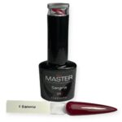 | NailMaster | Sangria 7,5ml – 01  Artikelnummer: Pu01-C0152NM914-7,5ML1 | €0,00 | × 1
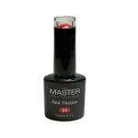 | NailMaster | Red Passion 20 /7,5ml  Artikelnummer: Gl20-Md2420NM914-7,5ML1 | €0,00 | × 1
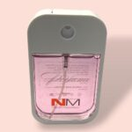 | Perfume Rose 38ml  Artikelnummer: Rose .NM929-38ML | €0,00 | × 1
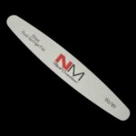 | NM Dual Sponge File 180/150 grid - 1 stuk  Variatie-ID: 12580 | €0,00 | × 5
  Hoeveelheid: | 1 stuk
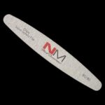 | NM Ellips Salon Safety File 180/180 grid - 1 stuk  Variatie-ID: 12554 | €0,00 | × 5
  Hoeveelheid: | 1 stuk
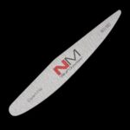 | NM Expert File 180/180 grid - 1 stuk  Variatie-ID: 12571 | €0,00 | × 5
  Hoeveelheid: | 1 stuk
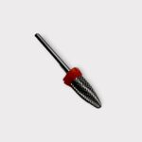 | Carbide 2 Way Corn bit F (link en rechtshandig red band)  Artikelnummer: 127119031505 | €0,00 | × 1
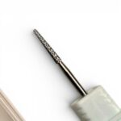 | Under the nail bit/cuticle titanium Medium | €0,00 | × 1
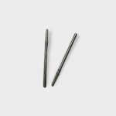 | Cuticle bit oval lang - diamond - 2.0mm(rond kop) | €0,00 | × 1
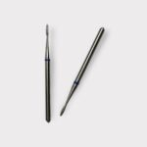 | Flame manicure bitje - mini detail | €0,00 | × 1
 | Cuticle bit oval lang- diamond- 1.2mm (rond kop) | €0,00 | × 1
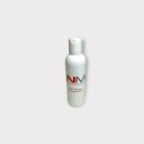 | NailMaster | Gel Cleaner - 100ml | €0,00 | × 1
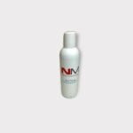 | NailMaster | Nail Fresh - 100ml  Artikelnummer: OOO-NaFrNm2106A012ML-100ML | €0,00 | × 1
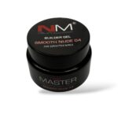 | NailMaster | Builder gel SMOOTH NUDE 04/30ml TPO/HEMA FREE  Artikelnummer: 24,95 | €0,00 | × 1
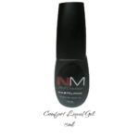 | NM Comfort Gel PASTEL PINK 15ml | €0,00 | × 1
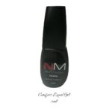 | NM Comfort Gel NATURAL 15ml TPO free  Artikelnummer: CoLiNa-NM515912-15ML | €0,00 | × 1
 | NM Comfort Liquid Gel NUDE 15ml TPO free  Artikelnummer: CoLiNu-NM525912-15ML | €0,00 | × 1
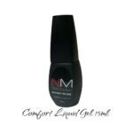 | NM Comfort Liquid Gel NUDE ROSE 15ml TPO free  Artikelnummer: CoLiNuRo-NM545912-15ML | €0,00 | × 1
NM Comfort Liquid Gel SANDY ROSE 15ml TPO free
Artikelnummer: CoLiSaRo-NM555912-15ML

Totaal pakket kosten: € 725,96 excl. 21%btw / BTW: € 152,45 / Subtotaal incl. btw € 878,41

